

**FUTURE INSTITUTE OF ENGINEERING AND MANAGEMENT**

**CC – 148**

**UNDER**

**MAKAUT, WB**

MINI PROJECT ON:

VEHICLE SPEED MEASUREMENT DEVICE

**SUBMITTED BY**

**ROHAN PRAMANIK (14800320026)**

**APURBA SAMANTA(14800320010)**

**B. TECH (ECE, 3RD YEAR)**

**6TH SEMESTER**

**Academic Year: 2022-23**

**Introduction -** The purpose of this report is present the measurement of vehicle speed. This project aims to improve traffic safety at a busy location.

**Project Concept -** The vehicle speed measurement device is a project concept that aims to design and develop a system that can accurately measure the speed of a vehicle on the road. The device will use various sensors and technologies to detect the movement of the vehicle and calculate its speed. Here are some key components and features of the proposed device. Overall, the vehicle speed measurement device will provide an accurate and reliable way for drivers to monitor their speed and ensure they are driving within the legal limits. The device may also have applications in other areas, such as in speed limit enforcement or in vehicle tracking and monitoring.

**Component Used -**

* Arduino UNO
* I.R. Sensor
* 16 X 2 LCD Display With I2C Module
* Wires
* Breadboard
* Battery

**Objective -** He primary objective of the vehicle speed measurement device project is to design and develop a system that can accurately measure the speed of a vehicle on the road. This device aims to provide drivers with a reliable way to monitor their speed and ensure they are driving within the legal limits, thereby promoting road safety and preventing accidents caused by speeding.

The specific objectives of this project may include:

* Developing a reliable speed detection system that can accurately measure the speed of a vehicle in real-time.
* Implementing a user-friendly interface that can be easily operated by the driver, allowing them to monitor their speed and adjust their driving accordingly.
* Designing the device to be compact, weather-resistant, and easy to install on a vehicle's dashboard or elsewhere in the vehicle.
* Ensuring that the device provides accurate speed readings, even at high speeds, and under different weather and road conditions.
* Conducting testing and validation of the device to ensure that it meets the required accuracy and reliability standards.
* Investigating potential applications for the device, such as in speed limit enforcement or vehicle tracking and monitoring.

Overall, the objective of the vehicle speed measurement device project is to provide a reliable and accurate tool for drivers to monitor their speed and ensure safe driving practices on the road.

**Circuit Diagram –**

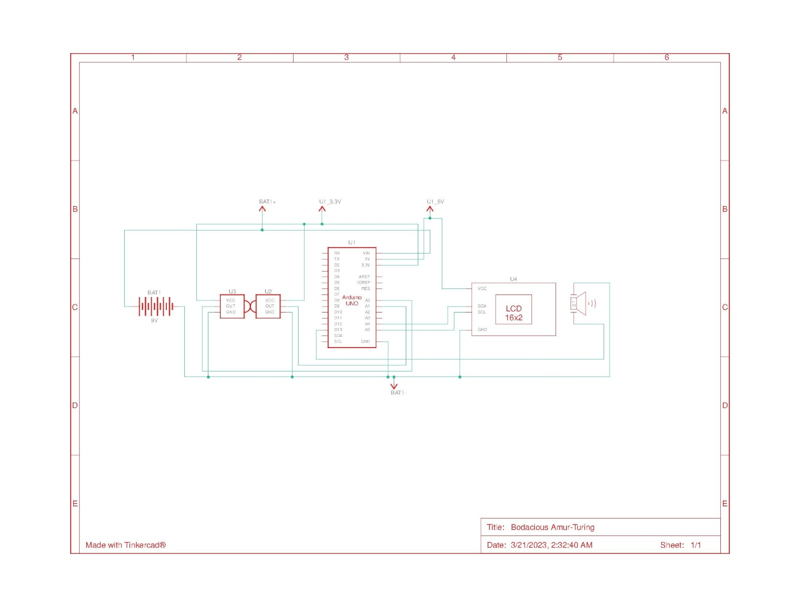

**Result -**  The result of the vehicle speed measurement device project would be a fully functional and reliable system that accurately measures the speed of a vehicle on the road. The device would have a user-friendly interface and be easy to install on a vehicle's dashboard or elsewhere in the vehicle.

**Code -**

#include<Wire.h>

#include<LiquidCrystal_I2C.h>

LiquidCrystal_I2C lcd(0x27,16,2);

int timer1;

int timer2;

float Time;

int flag1 = 0;

int flag2 = 0;

float distance = 5.0;

float speed;

int ir_s1 = A0;

int ir_s2 = A1;

int buzzer = 13;

void setup(){

// initialize the LCD

lcd.begin();

// Turn on the blacklight and print a message.

lcd.backlight();

pinMode(ir_s1, INPUT);

pinMode(ir_s2, INPUT);

pinMode(buzzer, OUTPUT);

lcd.clear();

lcd.print(" WELCOME To FIEM ");

delay(2000);

lcd.clear();

}

void loop() {

if(digitalRead (ir_s1) == LOW && flag1==0){timer1 = millis(); flag1=1;}

if(digitalRead (ir_s2) == LOW && flag2==0){timer2 = millis(); flag2=1;}

if (flag1==1 && flag2==1){

if(timer1 > timer2){Time = timer1 - timer2;}

else if(timer2 > timer1){Time = timer2 - timer1;}

Time=Time/1000;//convert millisecond to second

speed=(distance/Time);//v=d/t

speed=speed*3600;//multiply by seconds per hr

speed=speed/1000;//division by meters per Km

}

if(speed==0){

lcd.setCursor(0, 1);

if(flag1==0 && flag2==0){lcd.print("No car detected");}

else{lcd.print("Searching... ");}

}

else{

lcd.clear();

lcd.setCursor(0, 0);

lcd.print("Speed:");

lcd.print(speed,1);

lcd.print("Km/Hr ");

lcd.setCursor(0, 1);

if(speed > 50){lcd.print(" Over Speeding "); digitalWrite(buzzer, HIGH);}

else{lcd.print(" Normal Speed "); }

delay(2000);

digitalWrite(buzzer, LOW);

speed = 0;

flag1 = 0;

flag2 = 0; }}

**Application –**

The Vehicle Speed Detection System using IR Sensor has a wide range of applications, some of which are listed below

* Traffic Management: The system can be used to manage traffic and ensure that vehicles are not speeding on the roads.
* Law Enforcement: The system can be used by law enforcement agencies to monitor the speed of vehicles and catch those who are breaking the speed limit.
* Highway Safety: The system can be installed on highways to ensure that vehicles are not speeding, thereby reducing the risk of accidents.
* Smart Cities: The system can be used in smart cities to monitor the speed of vehicles and manage traffic in real-time.

**Advantage -**

* Improved road safety: The device helps promote road safety by providing drivers with a reliable way to monitor their speed and ensure they are driving within the legal limits, thereby preventing accidents caused by speeding.
* Accurate speed readings: The device provides accurate speed readings, even at high speeds and under different weather and road conditions, allowing drivers to adjust their speed accordingly.
* User-friendly interface: The device has a user-friendly interface that can be easily operated by the driver, allowing them to monitor their speed without distracting from driving.
* Easy to install: The device is compact and easy to install on a vehicle's dashboard or elsewhere in the vehicle, making it accessible to a wide range of drivers and vehicles.
* Potential cost savings: The device may have applications in vehicle tracking and monitoring, which could help improve fleet management and reduce operating costs for businesses.
* Compliance with speed limit regulations: The device helps ensure compliance with speed limit regulations, reducing the risk of fines and legal consequences for drivers.

**Future Scope-**

1. Integration with other vehicle systems: The device could be integrated with other vehicle systems, such as GPS, to provide more comprehensive vehicle tracking and monitoring capabilities.
2. Data collection and analysis: The device could be used to collect data on vehicle speeds and driving patterns, which could be analyzed to improve road safety and traffic management.
3. Integration with smart cities: The device could be integrated with smart city systems to provide real-time traffic information and help manage traffic flow.
4. Advanced sensor technologies: Future versions of the device could use advanced sensor technologies, such as LiDAR or computer vision, to provide more accurate speed readings and additional data on the surrounding environment.
5. Mobile application integration: The device could be integrated with a mobile application, allowing drivers to access speed readings and other vehicle information remotely.
6. Integration with autonomous vehicles: The device could be used in autonomous vehicles to provide real-time speed readings and help ensure safe and legal driving practices

**Conclusion -** In conclusion, the Vehicle Speed Detection System using IR Sensor is an important tool for monitoring and controlling the speed of vehicles on the roads. The system is designed to be accurate, efficient, and user-friendly, with low-cost components that make it accessible to a wide range of users. Its real-time monitoring capabilities and versatility make it a valuable tool for improving road safety, managing traffic, and reducing the risk of accidents. The system has a wide range of applications, including traffic management, law enforcement, highway safety, and smart cities. Overall, the Vehicle Speed Detection System using IR Sensor is a highly effective solution for measuring the speed of vehicles and ensuring that they are not speeding on the roads.

**THANK YOU…**

**STUDENT’S SIGNATURE TEACHER’S SIGNATURE**